Questions:

1. Two new flights are scheduled to leave from *BOS* to *ORD* airports.
   * The first flight (*flightId 1111*) will be on airplane *AP098640* departing on-time at 2018-11-05 12:00:00 and arriving on-time at 2018-11-05 14:30:00.
   * The second flight (*flightId 1112*) will be on airplane *AP432379* departing on-time at 2018-11-05 22:00:00 and arriving on-time at 2018-11-06 00:30:00.

**SQL QUERY:**

set xact_abort on;

begin transaction addtrans1

insert into FlightRoute_t(flightNumber,departAirport,arriveAirport,scheduledDepartTime,scheduledArrivalTIme)

values(1111,'BOS','ORD','12:00:00','14:30:00'),(1112,'BOS','ORD', '22:00:00','00:30:00')

insert into FlightSchedule_t(flightNumber,flightDate,statusID,airplaneID,delayDepartTime,delayArrivalTime)

values(1111,'2018-11-05','O','AP098640',NULL,NULL),(1112,'2018-11-05','O','AP432379',NULL,NULL)

commit transaction addtrans1;

SELECT * FROM FlightRoute_t where flightNumber='1111' or flightNumber='1112'

SELECT * FROM FlightSchedule_t where flightNumber='1111' or flightNumber='1112'

**SCREENSHOT:**

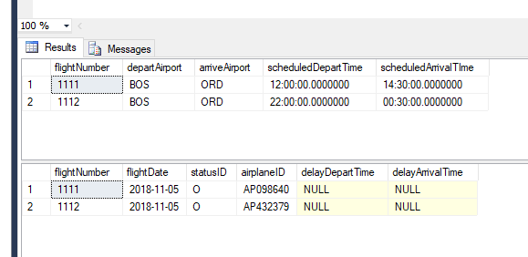

1. Due to forecasted inclement weather, the new flights’ **statuses** have changed.
   * The earlier new flight from *BOS* to *ORD (flightId 1111)* has been ***delayed*** by 10 hours.
   * The later new flight from *BOS* to *ORD (flightId 1112)* hasbeen ***canceled***.
   * **NOTE:** DO NOT commit this transaction *(i.e. COMMIT TRANSACTION …;)*

**SQL QUERY:**

set xact_abort on;

begin transaction updatetrans1

update FlightSchedule_t

set FlightSchedule_t.statusID='D'

from FlightSchedule_t

where flightNumber=1111;

update FlightSchedule_t

set statusID='C'

from FlightSchedule_t

where flightNumber=1112;

update FlightSchedule_t

set delayDepartTime = '10:00:00.0000000'

from FlightSchedule_t

where flightNumber=1112;

**SCREENSHOT:**

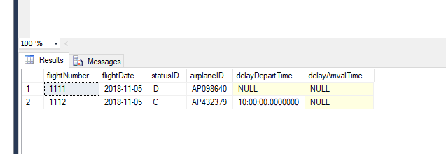

1. The weather has improved and the two flight are back to the original statuses (*question 1*).
   * ROLLBACK the last transaction (2)
   * ***NOTE****: If you committed the transaction in (2), you’ll be unable to Rollback.* Revert instead using a new transaction with update statements.

**SQL QUERY:**

ROLLBACK TRANSACTION updatetrans1;

SELECT * FROM FlightSchedule_t where flightNumber='1111' or flightNumber='1112'

**SCREENSHOT:**

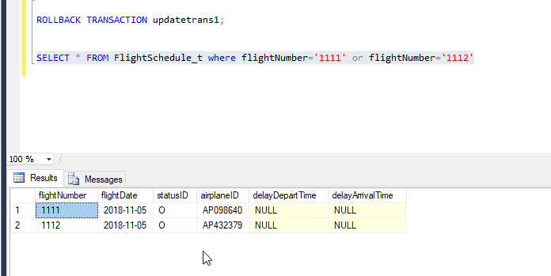

1. There is a new flightRoute between Portland, OR (*cityID C010*) and Seattle, WA (*cityID C011*).
   * The Portland airport is airportId *PDX* and is named *Portland International Airport*.
   * The Seattle airport is airportId *SEA* and is named *Seattle–Tacoma International Airport*.
   * The flight from PDX to SEA *(flightID 1003*) is scheduled to depart at *08:00:00 and arrive at 09:15:00.*
   * The flight from SEA to PDX (*flightID 1004*) is scheduled to depart at *14:00:00 and arrive at 15:15:00*.
   * ***NOTE:*** *No flights have been scheduled yet for this flightRoute.*

**SQL QUERY:**

set xact_abort on;

begin transaction addtrans3

insert into states_t values ('OR','Oregon');

insert into states_t values ('WA','Washington');

insert into City_t values ('C010','OR','Portland');

insert into City_t values ('C011','WA','Seattle');

INSERT INTO Airport_t VALUES ('PDX','C010','Portland International Airport');

insert into Airport_t values ('SEA','C011','Seattle–Tacoma International Airport');

INSERT INTO FlightRoute_t VALUES('1003','PDX','SEA','08:00','09:15');

INSERT INTO FlightRoute_t VALUES('1004','SEA','PDX','14:00','15:15');

commit transaction addtrans3;

select * from states_t;

select * from City_t;

select * from Airport_t;

select * from FlightRoute_t;

**SCREENSHOT:**

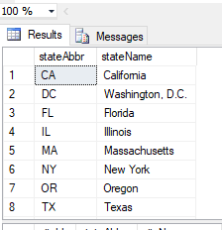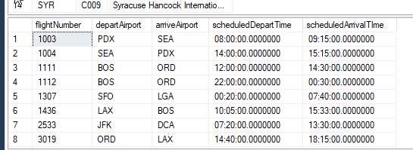

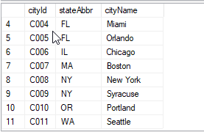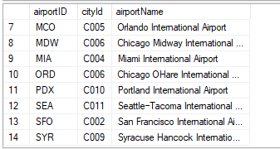

Views

Directions:

Create a view based on the criteria in question (1). Take a screenshot of the SQL query which generated the view and take a screenshot of the result table when you **SELECT * FROM *view***.

1. An operations analyst is interested in understanding flight capacity at each airport. In order to do so, they need to continually monitor how many departing and arriving flights occur at each airport.

To assist the analyst, create a **VIEW** called *Airport_Capacity* with the following columns:

* *airportId, airportName, cityId, cityName, stateAbbr, StateName*
* View contains the total number of departing and arriving flights for each airport
* The view **excludes** airports which have no departing and arriving flights

**SQL QUERY:**

go

create view view1 as

select t3.airportID,t3.airportName,t3.cityId,t2.cityName,t2.stateAbbr,t1.stateName

from states_t as t1

inner join City_t t2 on t1.stateAbbr = t2.stateAbbr

inner join Airport_t t3 on t2.cityId = t3.cityId;

go

go

create view view2 as

select COUNT(flightNumber) as departing,departAirport from FlightRoute_t group by departAirport;

go

go

create view view3 as

select COUNT(flightNumber) as arriving, arriveAirport from FlightRoute_t group by arriveAirport;

go

go

create view Airport_Capacity as

select t1.*,t2.departing,t3.arriving from view1 as t1

inner join view2 as t2 on t1.airportID=t2.departAirport

inner join view3 as t3 on t1.airportID= t3.arriveAirport;

go

select * from

Airport_Capacity;

**SCREENSHOT:**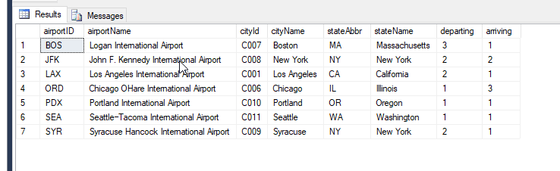

1. Query the *Airport_Capacity* view and return the distinct states (*DISTINCT stateAbbr*) where the number of departures is greater than or equal to the number of arrivals.

**SQL QUERY:**

select distinct(stateAbbr) from Airport_Capacity

where departing > arriving;

**SCREENSHOT:**

